Original article (Times New Roman, 10-point size)
Format instructions of the manuscripts for IIW 2023 international conference
(Times New Roman, Bold, 16-point size, 1.2 line spacing. Please note that the number of pages of your paper must be between 5 and 8)
First A. Author ª, Second B. Author ^{b}, Third C. Author ^{c}, Fourth D. Author ª*
(Times New Roman, Bold, 12-point size, 1.2 line spacing)
a. Business or Academic Affiliation, City, State (Province) Postal Code, Country
b. Business or Academic Affiliation, City, State (Province) Postal Code, Country
c. Business or Academic Affiliation, City, State (Province) Postal Code, Country
(Times New Roman, Italics, 10-point size, 1.2 line spacing)
(NOTE: Present the authors' affiliation addresses (where the actual work was done) below the names. Indicate all affiliations with a lower-case superscript letter immediately after the author's name and in front of the appropriate address. Provide the full postal address of each affiliation, including the country name, and, if available, the e-mail address of each author. Mark the corresponding author with “*” on the top right and provide the contact information in the footer of the first page.)
Abstract: An abstract of 200 words or less should precede the introduction. The abstract should be a short summary that explains the main argument(s), topic(s) or findings of a manuscript. Use the PPR Writing Template.doc as a template if you are using Microsoft Word 2003 or later for Windows. Otherwise, use the Writing Template as an instruction set. Authors should make every effort to conform to the article structure given below for the preparation of manuscripts. Proper preparation of manuscripts will speed publication of articles. Improperly prepared manuscripts may be rejected or returned to the authors for correction before being accepted for publication. (The font is Times New Roman, 9-point size, and 1.2 line spacing.)
Keywords: Hybrid rocket motor; Water ramjet; Outlet guide vane (OGV); Reynolds-averaged Navier-Stokes (RANS); Diffuser flow; Thermodynamic cycle; Thermal efficiency; Specific impulse
(Provide 5 to 8 keywords. The font is Times New Roman, 9-point size, 1.2 line spacing)

Nomenclature and abbreviations (Optional part, Times New Roman, Bold, 11-point size, 1.2 line spacing)
Manuscripts with many symbols should have a nomenclature which conforms to the system of standard international (SI) units. Nomenclature must be listed between the abstract and the introduction. If one is used, it must contain all the symbols used in the manuscripts.
Acronyms and abbreviations should be spelled out in full at their first occurrence in the text, for example, “sharp and monotonic algorithm for realistic transport (SMART)”, “Reynolds-averaged Navier-Stokes (RANS)”. In general, minimize the use of abbreviations so the paper remains easily understood by the general reader.
NOTE: The nomenclature, the abbreviations, the abstract, the keywords, the acknowledgements and the references should not be included in section numbering.
An example for nomenclature is shown below for your reference.
Nomenclature (Bold, 11-point size)
(Italics)  A | ( 8-point size)  thermal diffusivity (unit: m²/s)
c | massic heat capacity (unit: J/(kg•K))
E | modulus of elasticity (unit: Pa)
h | massic enthalpy (unit: J/kg)
I | impulse (unit: N•s)
m | mass (unit: kg)
M | coefficient of thermal insulation (unit: m²•K/W)
p | pressure (unit: Pa)
q | density of heat flow rate (unit: W/m²)
Q | heat (unit: J)
r | radius (unit: m)
R | molar gas constant (unit: J/(mol•K))
Ra | Rayleigh number
Re | Reynolds number
T | thermodynamic temperature (unit: K)
V | electric potential (unit: V)
w | electromagnetic energy density (unit: J/m³)
Greek letters
α | surface coefficient of heat transfer (unit: W/(m²•K))
λ | thermal conductivity (unit: W/(m•K))
τ | shear stress (unit: Pa)
ω | angular frequency (unit: rad/s)
Subscripts
g | gas
l | liquid
s | solid

1. Introduction (Times New Roman, Bold, 11-point size)
Use the PPR Writing Template.doc as a template if you are using Microsoft Word 2003 or later for Windows. Simply type your own text over sections of this document, or cut and paste from another document, the required spacing and formatting will be applied automatically.
Otherwise, use the PPR Writing Template.pdf as an instruction set, format your manuscripts.
Proper preparation of manuscripts will speed publication of articles. Improperly prepared manuscripts may be rejected or returned to the authors for correction before being accepted for publication of articles.
2. Format instructions (Times New Roman, Bold, 11-point size)
This section outlines general format instructions for the manuscripts. These instructions give you guidelines for the preparation of manuscripts.
2.1. Page setup (Times New Roman, Italics, 10-point size)
Set the page parameters for your manuscripts. The detailed page setup parameters are listed in Table 1.
Table 1 Detailed list of the page setup parameters for the manuscripts. (Times New Roman, 8-point size)
Page setup |  | Value
Page size | Page width | 210 mm
 | Page height | 280 mm
Page margin | Top margin | 28 mm
 | Bottom margin | 20 mm
 | Left margin | 20 mm
 | Right margin | 20 mm
Column | Column number | 2
 | Column spacing | 6 mm
 | Column width | 82 mm

2.2. Font style and line spacing (Times New Roman, Italics, 10-point size)
The default font for the manuscripts is Times New Roman and the default line spacing is 1.2. Please use Times New Roman and 1.2 line spacing in all parts of your manuscripts, including text, title, footer, table, figure, reference, and so on.
Set the font style for your manuscripts. The detailed parameters of font style are listed in Table 2.
2.3. Detailed instructions (Times New Roman, Italics, 10-point size)
The detailed instructions and examples for all paragraphs of manuscripts are shown in Table 2.
The information summarized in Table 1 and Table 2 can quickly and efficiently help you format your manuscripts.

Table 2 Detailed list of the font size and the detailed instructions for the manuscripts. (Times New Roman, 8-point size)
Paragraph | Font size | Detailed instructions | Example
Article title | 16-point | Bold, justify-left, and capitalize the first letter of the first word in the article title | Article title
Author name | 12-point | Bold, justify-left, and provide the full names of all authors | First A. Author
Author affiliation | 10-point | Italics, justify-left | Affiliation, City, State (Province) Postal Code, Country
Abstract | 9-point | Bold label + Normal text, 300 words or less | Abstract: Abstract text
Keywords | 9-point | Bold label + Normal text, 5 to 8 keywords | Keywords: Keywords text
Nomenclature | 8-point | Italics variables + Normal text | a thermal diffusivity (unit: m²/s)
First-level heading | 11-point | Bold, Arabic numeral + Heading | 1. First-level heading
Second-level heading | 10-point | Italics, Arabic numeral + Heading | 1.1. Second-level heading
Third-level heading | 9-point | Bold, Arabic numeral + Heading | 1.1.1 Third-level heading
Text | 9-point | Normal, indent the first line | The font in the text is Times New Roman, 9-point size. Indent the first line.
Acknowledgements | 9-point | Normal, indent the first line | Place acknowledgements in a separate section …
Reference | 9-point | Normal | [1] D. Bohn, SFB 561 …
Table caption | 8-point | Bold label + Normal caption, justify-center | Table 1 Table caption.
Figure caption | 8-point | Bold label + Normal caption, justify-center | Figure 1 Figure caption.
Footer | 8-point | Normal, the corresponding author and the copyright information | *Corresponding author: …

3. Equations (Times New Roman, Bold, 11-point size)
(1) Use the formula editor to create the equation.
(2) Equations are numbered consecutively, with equation numbers in parentheses.
(3) Variables are presented in an italic font style. Vectors and matrices should be used in bold italics.
(4) Ensure that symbols are defined in the Nomenclature or immediately follow the equation.
(5) When citing an equation in the text, use the abbreviation “Eq.” except at the beginning of a sentence, for example, “… as shown in Eq. (1)”, “… Eqs. (2) and (3)”, “Equation (1) illustrates that …”
The examples for equations are shown below.
4. Figures (Times New Roman, Bold, 11-point size)
(1) Figures can be in color or grayscale, or be black-and-white. Figures should have no background, borders, or outlines.
(2) Insert figures within your text. Number figures according to their sequence in the text. Use “Figure” instead of “Fig.” both in the text and in figure captions, for example, “Figure 1”, “Figure 2”. Ensure that each figure mentioned in the text actually exists.
(3) Ensure that each figure has a caption, and place the caption below its figure. If a figure has multiple parts, insert sub-caption, such as “(a)”, “(b)”, below each part and above the figure caption. Provide detailed information and minimize use of abbreviations in figure captions, and make sure your figures can be understood without reading the text.
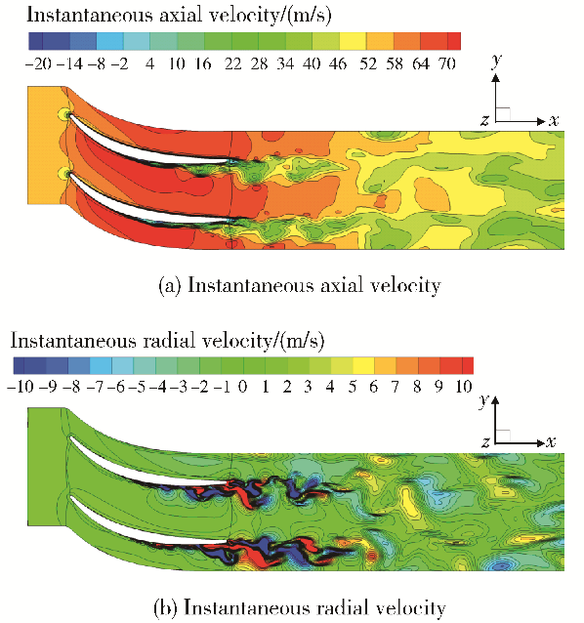
Figure 1 Large eddy simulation (LES) predicted contours of instantaneous axial velocity and radial velocity.
(NOTE: Column width figure should be less than 80 mm in width)
(4) The default font of figures is Times New Roman, 8-point size. Narrow the appropriate font only if there is no enough space to type the figure notes. Make sure all characters in figures are legible after reduction to typeset size.
(5) Full page width and column width figures should be less than 80 mm and 160 mm in width respectively, which are the maximum admitted widths for the page setup.
(6) Make sure figure images meet the demand of the print sharpness and quality. Various types of figures are as follows.
EPS format: Vector drawings. Embed the font or save the text as "graphics".
TIFF format: Color or grayscale photographs (halftones): always use a minimum of 300 dpi.
TIFF format: Bitmapped line drawings: use a minimum of 1000 dpi.
TIFF format: Combinations bitmapped line/half-tone (color or grayscale): a minimum of 500 dpi.
Figure 1 and Figure 2 show the examples for full page width and column width figures.

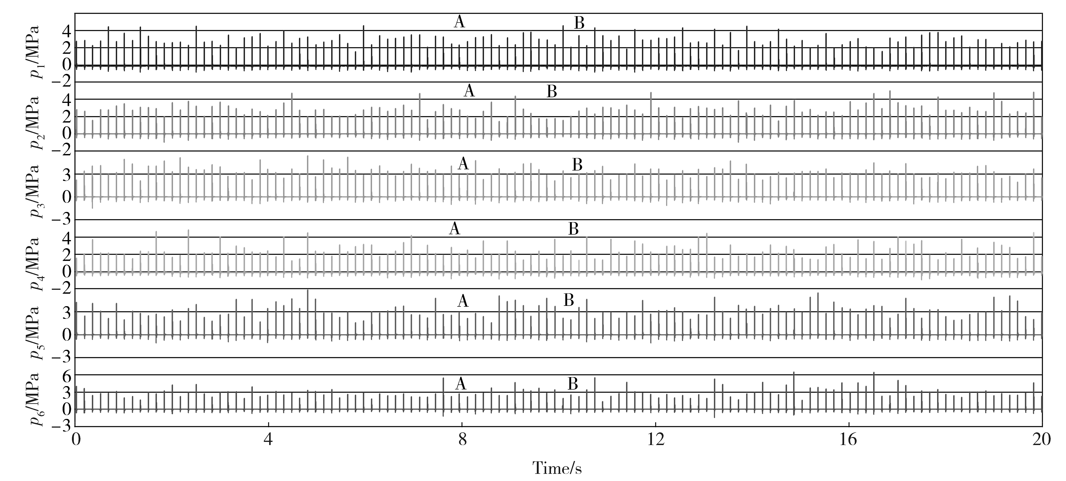
Figure 2 Pressure history of six-tube working together within 20 seconds. (Times New Roman, 8-point size)
(NOTE: Full page width figure should be less than 160 mm in width)

5. Tables (Times New Roman, Bold, 11-point size)
(1) Insert tables within your text, and number tables consecutively in accordance with their appearance. Do not abbreviate “Table” both in the text and in table captions, for example, “Table 1”, “Table 2”. Ensure that each table mentioned in the text actually exists. Ensure that each table has a caption, and place the caption above its table.
(2) The default font of tables is Times New Roman, 8-point size. Do not reduce font size even though there is not enough space.
(3) Place footnotes to tables below the table body and the font is Times New Roman, 8-point size.
(4) Minimize the use of symbols and abbreviations in the tables.
(5) Full page width and column width tables should be less than 80 mm and 160 mm in width respectively, which are the maximum admitted widths for the page setup.
Table 1 and Table 2 (see Section 2) are examples for full page width and column width tables.
6. Conclusions (Times New Roman, Bold, 11-point size)
Conclusions not only should review the main points of the scientific paper, but also should elaborate on the importance of the work or suggest applications and extensions.
Conclusions should not contain references to the cited literature.
Acknowledgements (Times New Roman, Bold, 11-point size, optional part, unnumbered)
Place acknowledgements in a separate section at the end of the manuscript before the references. List here those individuals who provided help or financial support during the research.
References (Times New Roman, Bold, 11-point size, unnumbered)
(1) Text: Indicate references by number(s) in square brackets in line with the text. The actual authors can be referred to, but the reference number(s) must always be given. For example: “… as demonstrated [3,4]. Barnaby and Jones [5] obtained a different result …”
(2) List: Number the references (numbers in square brackets) in the list in the order in which they appear in the text.
(3) All authors’ names should be given in the reference list, instead of using “et al”.
(4) In the reference list, papers that have not been published should be cited as “unpublished”; papers that have been submitted or accepted for publication should be cited as “submitted for publication.”
(5) Private communications and personal websites may be mentioned in the text, but should not be recommended in the reference list.

The following examples illustrate the recording form of different reference types. Cite references in your manuscript as follows. You are not required to indicate the type of reference. Different types are marked below with red letters for illustrative purposes only. All references should be in Times New Roman, 9-point size, 1.2 line spacing.

[1] D. Bohn, SFB 561: aiming for 65% CC efficiency with an air-cooled gas turbine, Modern Power Systems 26 (9) (2006) 25-29. (Periodical)
[2] G. Laschet, S. Rex, D. Bohn, R. Krewinkel, 3-D analysis of curved transpiration cooled plates and homogenization of their aerothermal properties, ASME Journal of Turbomachinery 129 (4) (2007) 791-799. (Revised version of GT2006-90377) (Periodical)
[3] F.L. Matthews, R.D. Rawlings, Composite Materials Engineering and Science, Second ed., Chapman & Hall, New York, 1994, pp. 12-16. (Book)
[4] R. Volpe, Techniques for collision prevention, impact stability, and force control by space manipulators, in: S.B. Skaar, C.F. Ruoff (Eds.), Teleoperation and Robotics in Space, Progress in Astronautics and Aeronautics, AIAA, Washington, DC, 1994, pp. 175-212. (Book)
[5] D. Bohn, R. Krewinkel, Effects of concave and convex curvature on the cooling effectiveness of effusion cooled multi-layer plates, in: K.D. Papailiou, F. Martelli, M. Manna (Eds.), Proceedings of the 7th European Turbomachinery Conference, Athens, Greece, 5-9 March 2007, pp. 967-977. (Proceedings)
[6] D. Bohn, R. Krewinkel, S. Tian, Cooling performance of grid-sheets for highly-loaded ultra-supercritical steam turbines, in: Proceedings of the 2nd International Symposium Jet Propulsion and Power Engineering, Guilin, P.R. China, September 22-26, 2008, Paper No. 2008-ISJPPE-2002. (Proceedings)
[7] Th. Fend, O. Reutter, J. Sauerhering, K.S. do Couto Aktay, R. Pitz-Paal, S. Angel, Effective thermal conductivity of metallic foams determined with the transient plane source technique, ECTP, Bratislava, September 4-8, 2005. (Report)
[8] J.M. Owen, Prediction of ingestion through turbine rim seals, part 2: externally-induced and combined ingress, ASME Paper GT2009-59122, 2009. (Report)
[9] K. Tseng, Nonlinear Green’s function method for transonic potential flow, Ph.D. Dissertation, Aeronautics and Astronautics Dept., Boston Univ., Cambridge, MA, 1983. (Thesis)
[10] J.C. Richard, G.C. Fralick, Use of drag probe in supersonic flow, in: AIAA Meeting Papers on Disc, AIAA, Reston, VA, Vol. 1, No. 2, 1996. (CD-ROM)
[11] Ramgen Power Systems, Low-cost, high-efficiency CO₂ compressor, URL: http://www.carboncouncil.org/pdf/pres entations/technologies_baldwin.pdf [cited 05 December 2007]. (Online database)
[12] C.P. Atkins, J.D. Scantelbury, The activity coefficient of sodium chloride in a simulated pore solution environment, Journal of Corrosion Science and Engineering, Vol. 1, No. 1, Paper 2, URL: http://www.cp/umist.ac.uk/JCSE/vol1/ vol1.html [cited 13 April 1998]. (Online journal)
[13] B.O. Muthén, Mplus, Version 5.1, Los Angeles, CA, 1998. (Computer software)
[14] R. Scherrer, D. Overholster, K. Watson, Lockheed Corp., Burbank, CA, U.S. Patent Application for a “Vehicle,” Docket No. P-01-1532, filed 11 Feb. 1979. (Patent)

